Software introduction
The software is a powerful integrated central control software, set multi-window, multi-user, multi-language, voice intercom, video conferencing, graded electronic map, alarm center, compatible with other extended products, stand-alone direct equipment monitoring system and other functions as a whole. The software has electronic map function, friendly interface, simple operation, can easily set permissions.
This software is for connecting multiple different types or models of equipment (e.g. DVR, DVS, etc.), this manual is only for software operation, related to the specific device's functional settings please read the relevant product manual.
This manual is provided to anyone responsible for planning, executing, or reviewing the hardware installation of network video surveillance software. You should have basic operational knowledge and experience with related equipment (e.g. DVR, DVS, etc.).

Features

User and rights management
The system supports three levels of organizational management, as well as user management and rights settings management.

Data interface technology is used
All data interactions in the system use data interface technology to flexibly support a wide range of small and medium-sized databases, such as SQL,MYSQL, and XML data.

SUPPORTS EXCEL TABLE EDITING TO ADD DEVICES.
Support users to use .bin files for the import and export of equipment, convenient for users to carry out high-volume equipment maintenance, improve the ease of use of the system and greatly reduce the workload of user maintenance.

Smart video transfer protocol.
Using intelligent video transmission protocol to maximize the use of network bandwidth, especially for front-end network bandwidth is limited, the system in order to ensure image quality on the basis of low network bandwidth, but also to ensure the normal operation of the system.

Perfect video surveillance.
While supporting real-time monitoring, the system supports alarm recording, automatic monitoring video, video playback, etc., and can accurately control the recording of each channel.

Dynamically adjust the decoding buffer.
Real-time monitoring can flexibly adjust the smoothness of video images or real-time priority, smoothness of video images, real-time emphasis on real-time video images, to meet the needs of different users.

Centralized management.
The entire system is managed in a centralized data set. Remote users can monitor or record recordings in real time, anytime, anywhere over the network.

Good ease of operation.
Under the control of permissions, users can easily control and set up each monitoring point through the system client, and the system also integrates the electronic map function.

High level of integration.
The system integrates other relevant information, such as alarm information, voice information, etc.

High reliability.
The system designs special fault tolerance measures to ensure the integrity of the data and the reliable operation of the system.

Good scalability.
System service-oriented design, has good scalability and adaptability, can maximize the protection of user investment.

Electronic map support.

Supports multiple simultaneous playback.

Multi-devices can be connected at the same time and multi-device video (real-time monitoring and playback).

XML data storage.

Supports a variety of rocker keyboard protocols

Supports a variety of alarm devices, such as CK, Vista, etc

Support for a variety of 3D positioning fastball protocol, can be in the screen preview area to achieve 3D fixed and other operations

Installation instructions

Operating environment requirements

hardware
CPU P4/2.0G
The graphics card must support hardware scaling (e.g. ATI, TNT2 PRO) (recommended using ATI9800 and above graphics card, dual channel) memory 128M or more/128bit
Note: If the resolution of the device is high and the number of channels is high, memory, graphics card, cpu needs a higher configuration.
Network card: 100/1000M

Software
The software supports Vista/WinXp/Win2000/Win2003/Win7/win8/win10 and is not recommended to run under Windows 98.
Turn off all enabled antivirus software, firewalls, etc. on your computer before installing the software so that the control center can run the program correctly and write fully, otherwise you may not be able to search for the device.

The installation step

(1) Click on the 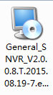VMS installer to install it, and the dialog box below appears to select the language.

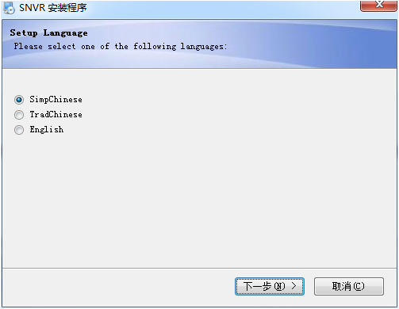

(2) Click "Next" to display the welcome screen,as shown below.

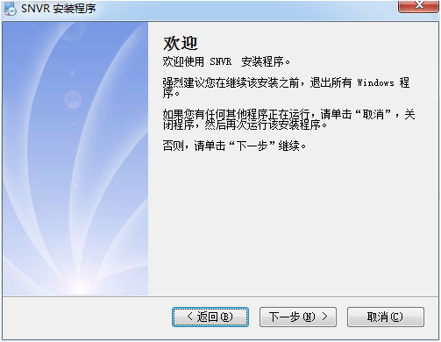

(3)Click Next to display the Select installation path interface

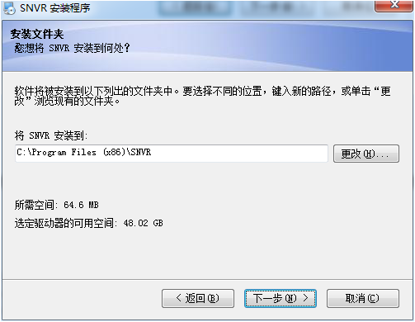

(4)Click Next to display the ready-to-install interface

(5) Click "Next" to install, display after installation, display the installation completion interface, click the "Done" button, complete the installation
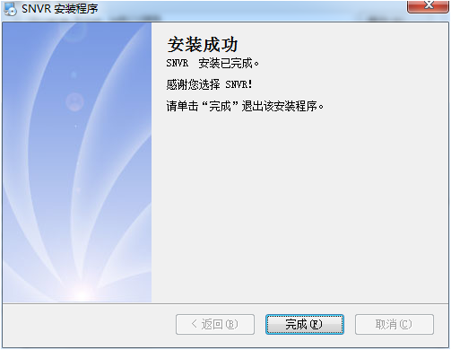

(6)Displays the login interface when it is complete
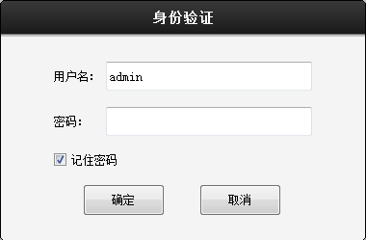

Description of the features

SVMS main interface
The main interface of the SVMS is shown below:
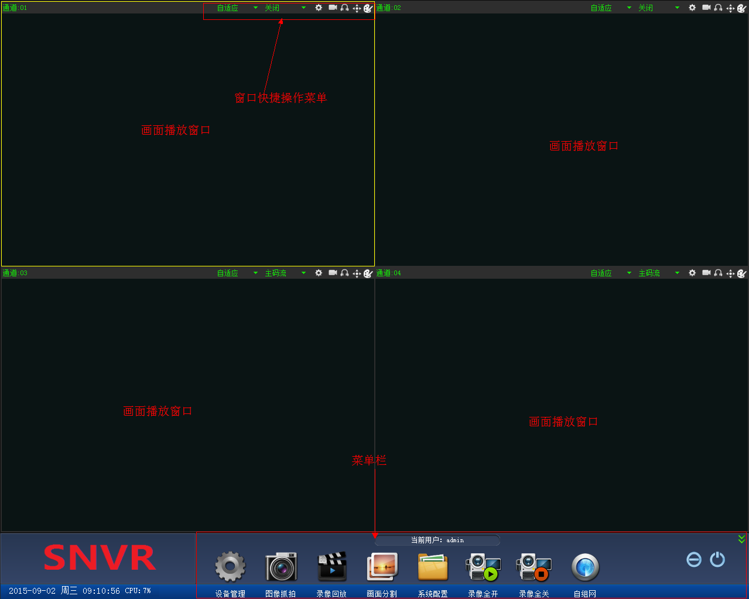

Device management
Click the Device Management button to 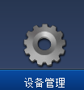open the Device Management interface, as shown below:

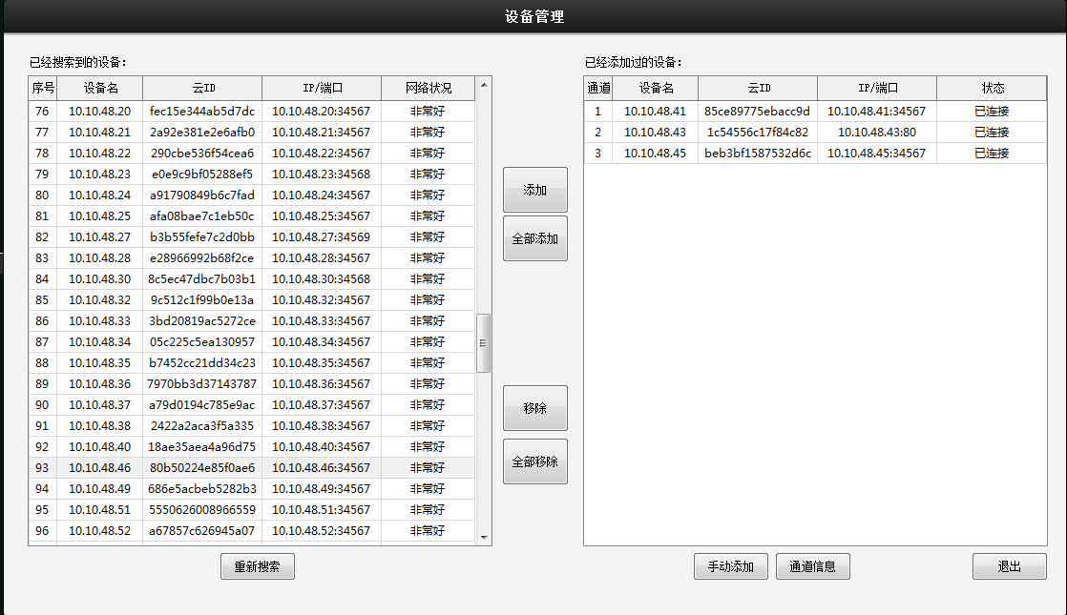

Search for devices and display the searched devices in the list of devices you've searched for
Add: Select a device in the list of devices you've searched for, and click Add to add the device to the list of devices you've added
Add All add all devices in the list of devices you've searched for to the list of devices you've added
Removes devices that need to be removed from the list of added devices, click the Remove button to remove them when selected
Remove All devices from the List of Added Devices
Add manually by manually adding serial number, username, password for device addition
Channel Information displays information for one channel

Image capture

Select a window with a picture and click on the "Image Capture" 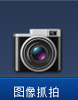button to display the capture information, as shown below

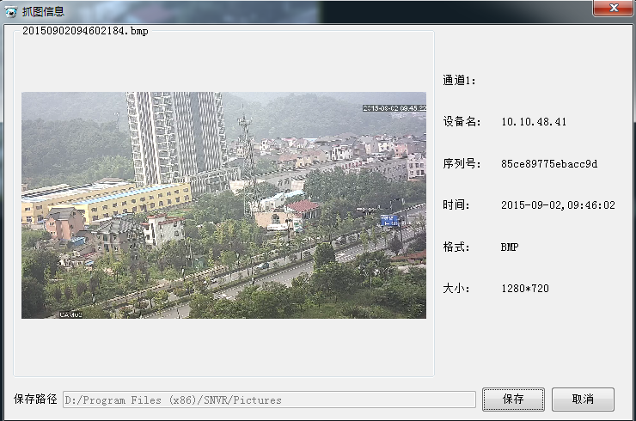

Click the "Save" button to save the picture to the appropriate path, and click the "Cancel" button to unsave the picture

Playback function

Click the "Record playback" button to enter the recording playback interface, as shown below:

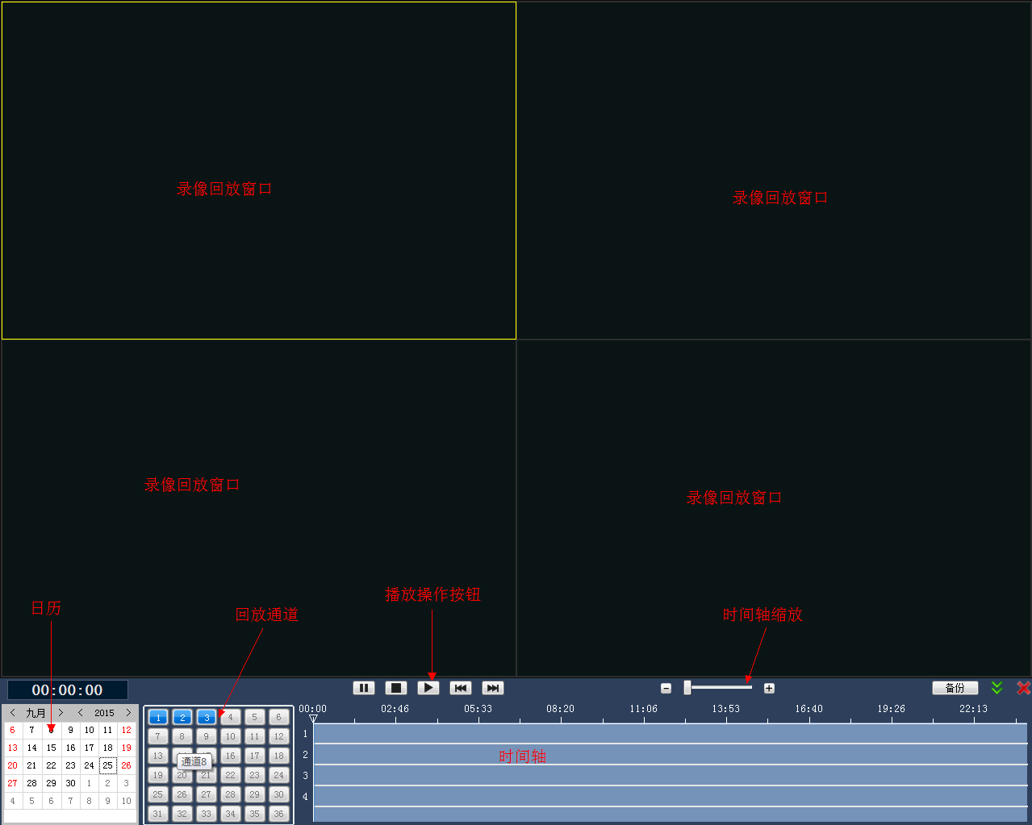

Calendar: Select the date on which you want to play back the recording (the date on which the recording is recorded will turn green)
Play back channels: Select the number of channels to play back
Play Action Button: The recording can be paused, stopped, played, slow, fast
Timeline Zoom zooms the timeline
Timeline shows the length of time the recording is made, and you can drag the cursor to change the playback progress

Click the "Back up" button, as shown below

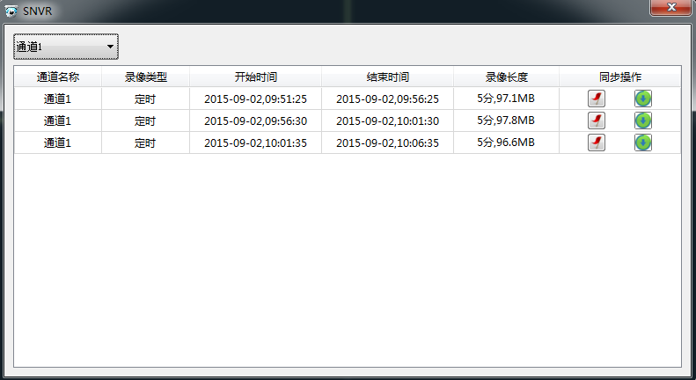
Clicking the "Locate to File" button opens the folder where the file is located
Clicking Convert to AVI format converts the file to an AVI format file

Clicking on the Full Screen button hides the recording playback action menu bar
Clicking on the "Close playback" button exits the recording playback interface

Split screen

Click on the screen split, 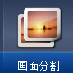as follows:

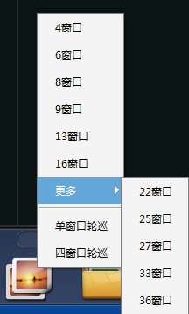

Click on the number of different windows to switch to the corresponding number of windows

System configuration

Click on the "System Configuration" button to enter the system configuration interface

The system environment
Select the system environment option, as shown below:

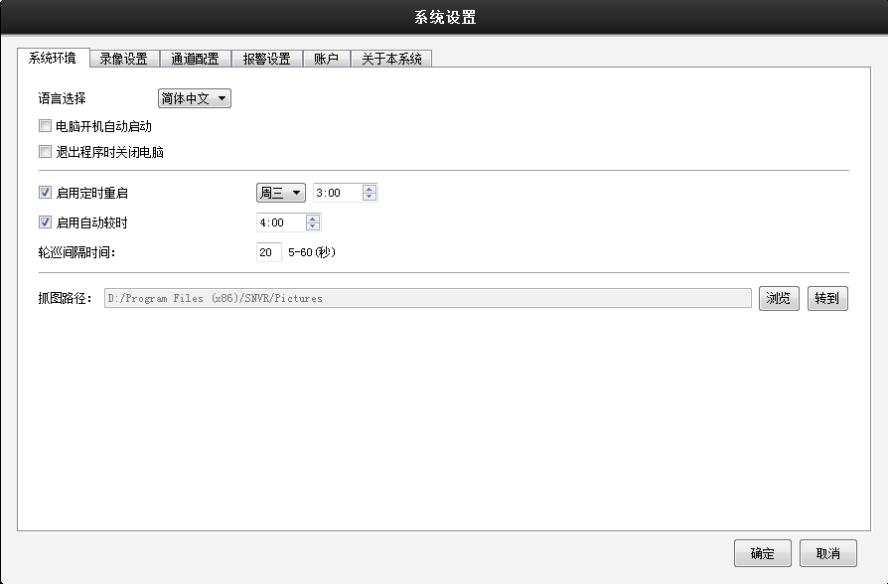

Language Selection: Select the SNVR language, choose Chinese and English
Computer Power On And Start Check Automatically Turns On The SNVR Software Whenever The Computer Is Turned On
Turn off your computer when you check Out, exit the SNVR software, and you'll turn off your computer
After checking, select the week, time, and set the time of the scheduled restart
Start School Time: Set the time of the automatic school hour, which will automatically be adjusted after the specified time
Wheel Tour Time sets the round tour time (5-60 seconds).
Capture Path: You can modify the path of the capture, click on the picture to save the picture under that path

Recording settings
Click on the "Record Settings" option, as follows:

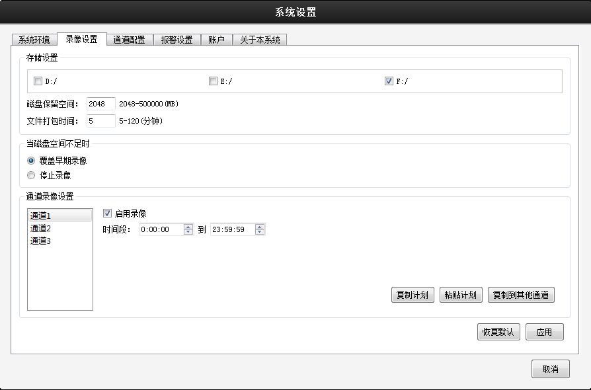

Storage Settings
Set the disk character of the recording file storage in the storage settings, the disk retention size, leave some reserved space for the disk when recording, the file packaging time, the file to the corresponding time to pack, when the disk space is full, stop recording or overwriting the early recording;

Video Settings
Select the appropriate window channel, and set the time period, check to turn on recording, and the window will automatically start recording at the set time.

Copy Plan to copy the current recording plan
Paste Plan: After copying the plan, select a different channel, click Paste Plan, you can paste the plan
Copy to Other Channels After copying the plan, click Copy to another channel, and you can modify the recording plan for the other channels to be consistent

Channel configuration

Modify the parameters of the main and secondary streams of the channel
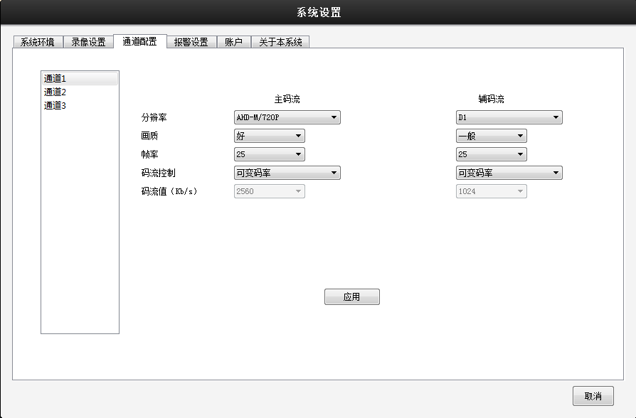

Channel: Select the channel number that needs to be set in the channel list;
Click on the drop-down menu to select the displayed resolution, with 1080P/720P/960H and other resolutions available
Frame Rate Click on the drop-down menu to select the frame rate at preview time, P-1-25 frames / second optional, N-1-30 frames / second optional;
Note: The frame rate becomes smaller and the smoothness of the picture becomes poorer but the stream value decreases.
Stream Control has two streaming strategies for limited and variable streams to choose from. Under variable stream, the picture quality is available in 6th gear and in the limited stream
Under, the code flow value can be artificially specified to make it more suitable for the current network environment;
When selecting variable stream in stream control, the picture quality is optional, the better the picture quality, the greater the stream value, and the size of the stream value varies with the scene
And change, the stream value of the motion scene is greater than the static scene, the complex stream value of the scene is greater than the stream value of the simple scene;
When selecting a limited stream in the code flow control, the stream value is optional, and no matter any change in the scene, the actual stream value fluctuates up and down in the set value, and no drastic changes occur;

Alarm settings

Select the Alarm Settings option, as shown below:

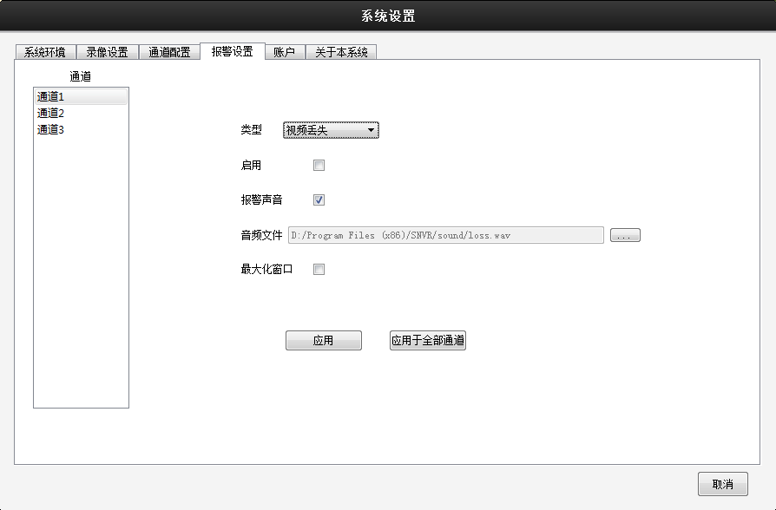

Type: Optional alarm type video loss,IO alarm, motion detection, video masking, disk full
When enabled, the appropriate type of alarm can be enabled
Alarm Sound: Check when enabled, and check the alarm sound, trigger the alarm will have an alarm sound
Audio file: The audio file used when the alarm is raised, and the alarm audio file used can be modified
When the Maximize Window is checked, an alarm is triggered and the corresponding channel is maximized

account

Click on the "Account" option, as follows:
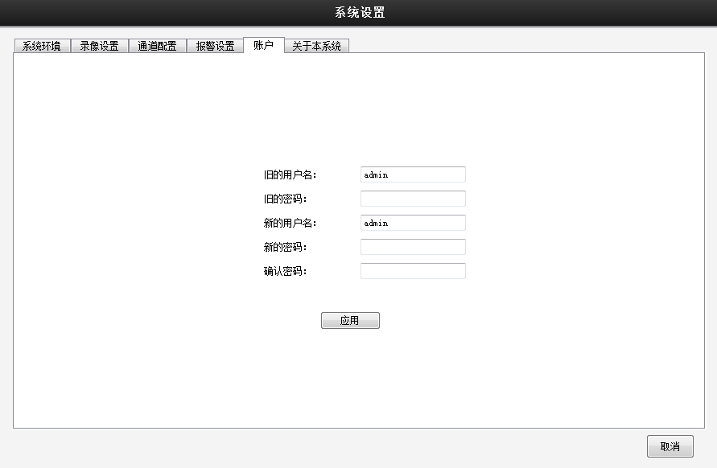

"Modify account" enter the correct old password, modify the new username, password, click on the app to complete the modification

About this system

Click on the "About the system" option, as shown below:

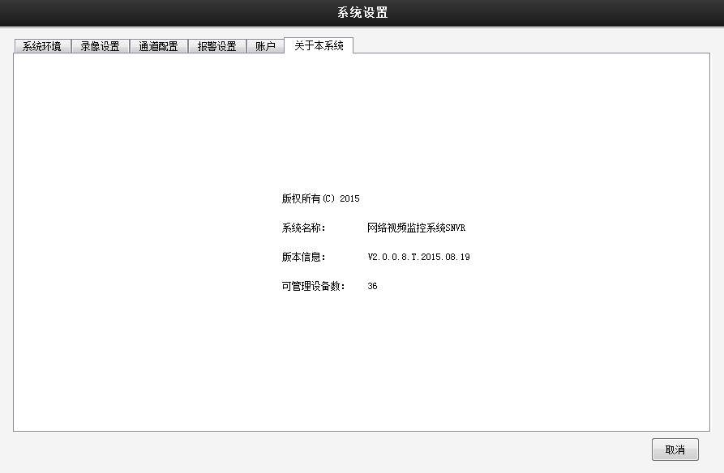

The video is fully on /off

Click the "Record All On" 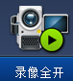button to turn on all current recording features with screen display channels

Click the "Recording All Off" 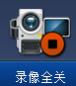button to turn off the recording function of all current recording channels

Self-networking
Click the "Self-networking" 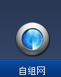button to automatically add nearby devices

The window shortcut menu

The window shortcut menu, as follows:

Window Operation Menu

You can adjust the scale of the watch screen in the window
The stream settings for the channel can be changed to
System settings, the same as system configuration functions
You can open/close the window to record
Audio that opens/closes the window
Control the gimble device
Controls the color of the image

Click on the system settings button to open the system settings interface, as shown below:
(same as system configuration)
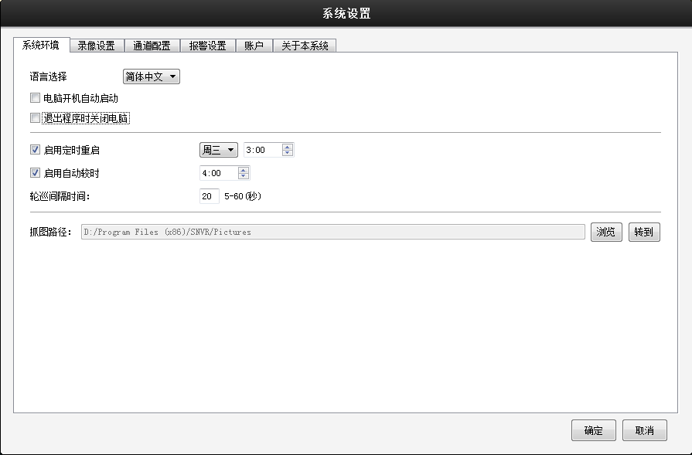
Click the head button to display the head operation box, as shown below:

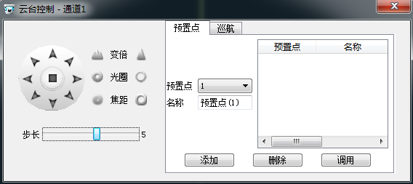

Analog Keyboard: Clicking on the simulated keyboard of the gimbal can control the rotation of the gimbal
Double: The image gets larger and larger when you click the Add button, and the opposite when you click the Reduce button
Aperture: The image gets brighter when you click the Add button, and the opposite when you click the Reduce button
Focus: The image becomes clearer when you click the Add button, and the opposite when you click the Reduce button
Step: Set steps 1-8, operate the head, the gimbal rotation span is getting larger and larger
Preset Points You can add a preset point by adding a button
Cruise: Take turns cruising between preset points

Click the Color button to display the image color action box, as shown below:

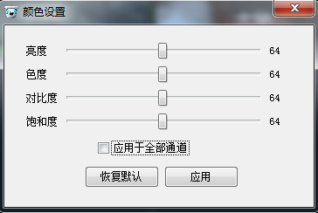

Right-click menu
Right-click to appear in the right-click menu, as shown below:

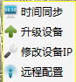

Time Sync: Sync your device with your local time after clicking

Upgrade your device

Click on the upgrade device option, as follows:

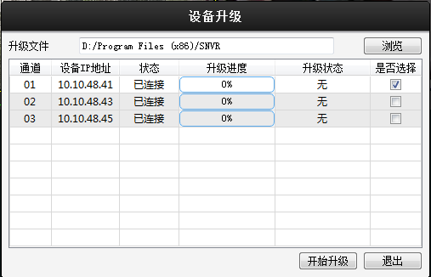

Select the upgrade file to upgrade the device

Modify the device IP

Click to modify the device IP option, as shown below:

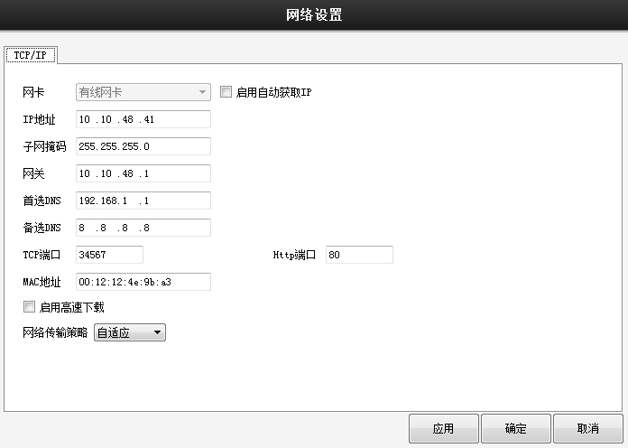

You can modify the device's IP address and port information

Remote configuration

Remote configuration
Right-click in the window to select the remote configuration option and display the remote configuration menu, as shown below:

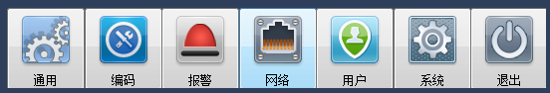
The remote configuration menu

general
Click the Universal button to display the common configuration operator interface

Universal options

Select the common option to display the common interface, as shown below:

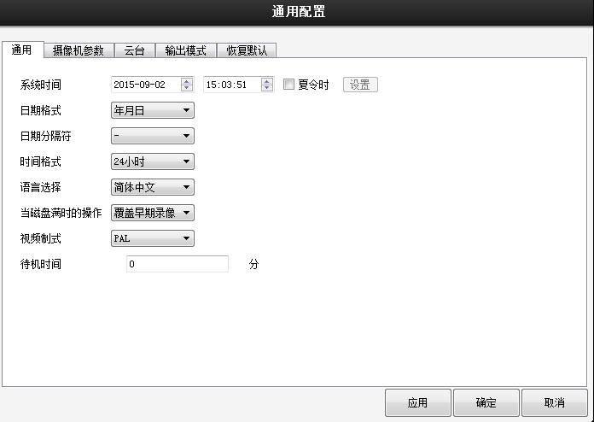

System Time: Set the time of the recorder system;
Daylight Saving Time: Check box before daylight saving time, and then click the Daylight Saving Time button to appear in the following image, you can set the video recorder time daylight saving time start and end time by week or date.
Date format, date separator: the format of the VCR preview interface to display the system time is set;
Time Format: Set the video recorder preview interface to display the time is 12 or 24 hours;
Language Selection currently supports 28 Chinese languages: Chinese Simplified, Chinese Traditional, English, Farsi/I, Finland, France, Greece, Hungary, Italy, Japanese, German, Poland, Portugal, Russian, Spanish, Thai, Turkish, Vietnamese, Romaniya, Brazil, Indonesian, Swedish, Arabic, Bulgarian, Czech, Hebrew, etc
When the hard drive is full, click on the drop-down menu to select stop, when the storage device installed in the recorder is full, that is, stop recording;
Select the overlay, then the storage disk device is full, continue recording, loop over the earliest recording files;
"Video system" drop-down menu hasPAL,NTSC two types of system optional, video recorder format needs to be consistent with the front-end camera format, no will lead to abnormal picture;
Standby time can be set menu standby time 0-60,0 is not set standby time;

Camera parameter options

Select the camera parameters option and open the camera parameters interface, as shown below:
The parameters of the camera can be set.

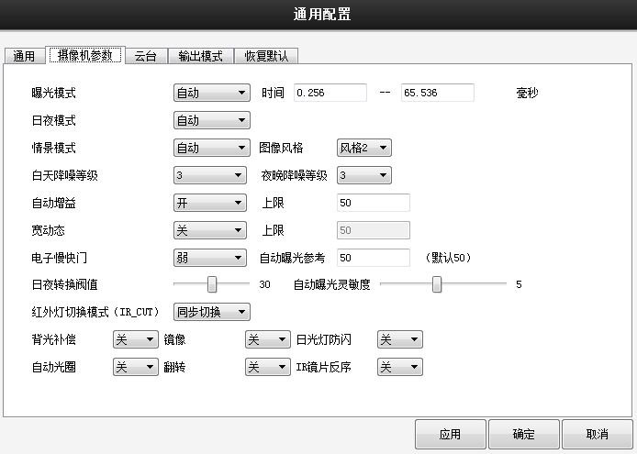

The gimm?
Click on the Head option to open the Head Settings interface, as shown below:

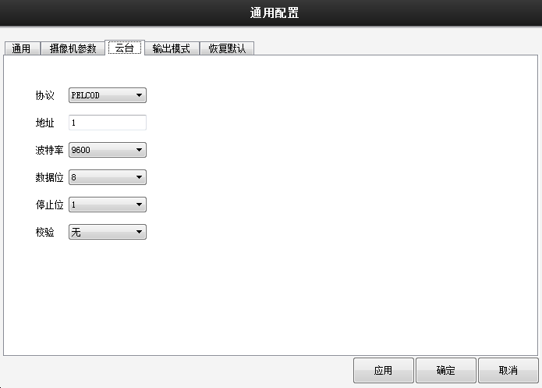

"Protocol" click on the drop-down menu to select the agreement supported by the gim top;
Address is set to the address where you need to control the head, and the default is 1;
Baud Rate click on the drop-down menu to select the Baud Rate supported by The Head, which defaults to 115200;
Data bits include 5-8 options, which default to 8 bits;
Stop Bit has 1,2 options, and the default is 1;
Check: Divided check, parity, mark check, air check, default to none.
Note: The VCR protocol, address, and baud rate must be consistent with the front-end head, otherwise it will not be controlled.

Output mode options

Select the input mode option to open the output mode interface, as shown below:

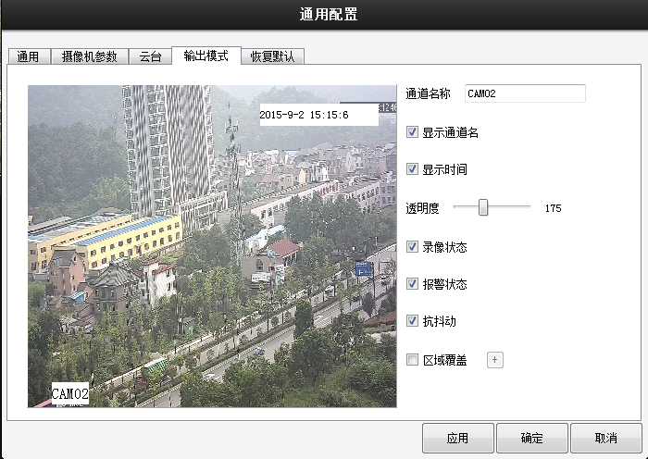

You can modify the channel name, display or hide the channel name, and display the time
Modify the transparency, set whether the recording status is displayed on the device side, alarm status
Area coverage: For areas of the picture that do not want to be photographed, use area coverage, cover with black blocks.

Restore the default option

Select the restore default option to open the recovery default interface, as shown below:

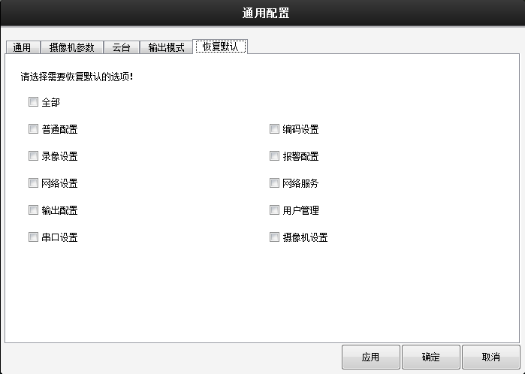
Select the option to restore the default click OK to revert to the default settings

encode

Click the encoding button 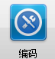to enter the encoding configuration interface, as shown below:

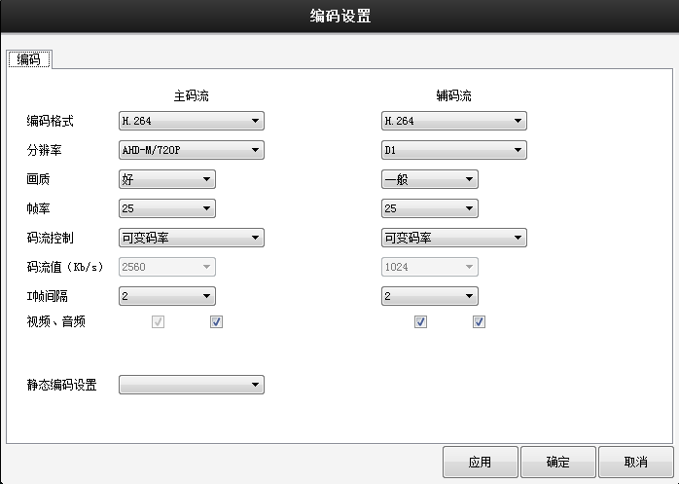

Coding Mode Standard H.264;
Click on the drop-down menu to select the displayed resolution, with 1080P/720P/960H and other resolutions available
Frame Rate Click on the drop-down menu to select the frame rate at preview time, P-1-25 frames / second optional, N-1-30 frames / second optional;
Note: The frame rate becomes smaller and the smoothness of the picture becomes poorer but the stream value decreases.
Stream Control has two streaming strategies for limited and variable streams to choose from. Under variable stream, the picture quality is available in 6th gear and in the limited stream
Under, the code flow value can be artificially specified to make it more suitable for the current network environment;
When selecting variable stream in stream control, the picture quality is optional, the better the picture quality, the greater the stream value, and the size of the stream value varies with the scene
And change, the stream value of the motion scene is greater than the static scene, the complex stream value of the scene is greater than the stream value of the simple scene;
When selecting a limited stream in the code flow control, the stream value is optional, and no matter any change in the scene, the actual stream value fluctuates up and down in the set value, and no drastic changes occur;
I frame interval: key frame interval time,2-12 optional, key frame interval is smaller than the larger stream value, the better picture quality;
Audio / video after the audio check is to enable audio function, enable after clicking on the audio logo in the preview screen can be audio listening, auxiliary stream check can be through the secondary stream preview screen;
Coding Mode Click-down menu to choose from three coding strategies: High Profile, Main Profile, and Baseline, with HighProfile coding quality andBaseline lowest.

Enable active registration after checking
Serial number: Configure the serial number of the device
Server Address: Configure the server address of the device
Server Port: Configure the server port of the device
User Name: Configure the user name of the device
Password: Configure the password for the user name

alarm
Click the alarm button to display the alarm settings interface;

Select the mobile detection option, as shown below:
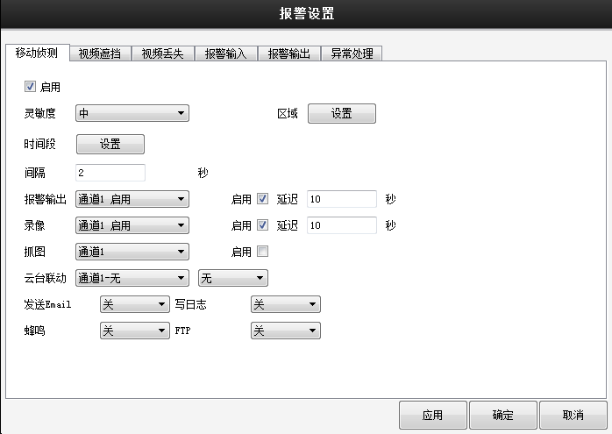

"Enable" box hook means selected, turn on mobile detection function, enable the corresponding settings;
"Sensitivity" alarm sensitivity has the lowest, lower, medium, high, high, the highest six-speed optional, the higher the sensitivity, the easier it is to trigger the alarm, false positive rate will also increase;

Area: Click on the settings, go to the locale page, the blue area for dynamic detection defense zone, as shown in the following image. Press and hold the right mouse button to mark out the settings area (all areas are selected as monitoring areas by default).
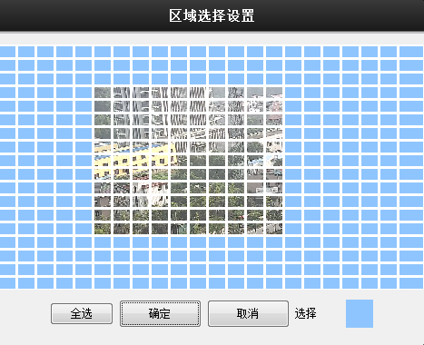

Time period: The recorder triggers a mobile detection alarm signal within the set time frame, as shown in the following image. You can set it up by week, or you can set it uniformly, with four time periods per day. Check the check box before the time period before the time period to set the time before it takes effect.

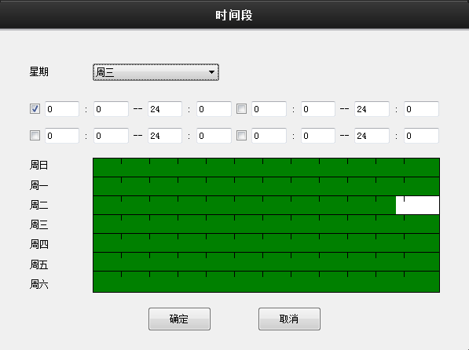

Interval time: In the set interval time, multiple trigger mobile detection alarm only output once alarm signal;
When the motion detection alarm is set to trigger, the channel number of the joint recording (checkable) is set, and when the alarm occurs, the recorder will record the selected channel
After setting the mobile detection alarm, the alarm output port continues to output the alarm signal for a period of time, setting the range of 10 to 300 seconds;
When setting the trigger motion detection alarm, the channel number of the linkage recording (can be checked), and when the alarm occurs, the video recorder will take a picture of the selected channel;
"Yuntai Operation" set the video recorder in the event of an alarm, call the selected channel head preset point, inter-point cruise or patrol;
Send EMAIL: When this function is enabled, the recorder sends an alarm message to the specified mailbox when the mobile detection alarm is triggered;
FTP Upload: When this function is enabled, the recorder will upload the alarm recording or picture to the specified FTP server when the mobile detection alarm is triggered;
Beep: Set the video recorder in the trigger alarm, the video recorder on the local host of the buzzer to sound a "buzz" tone;
When this function is enabled, the alarm information will be written to the system log information, and the user canquery the alarm log information in the Main Menu and Log Information
Mobile Phone Escalation: When the recorder triggers an alarm after enabling this function, the alarm information will be automatically pushed to the mobile device with the mobile customer installed;

Select the video masking option, as shown below:

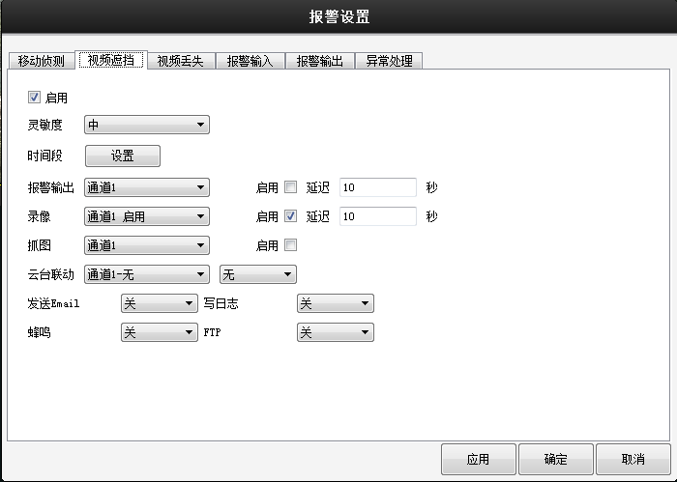

Option settings such as "Mobile Detection" above;

Select the video loss option as follows:

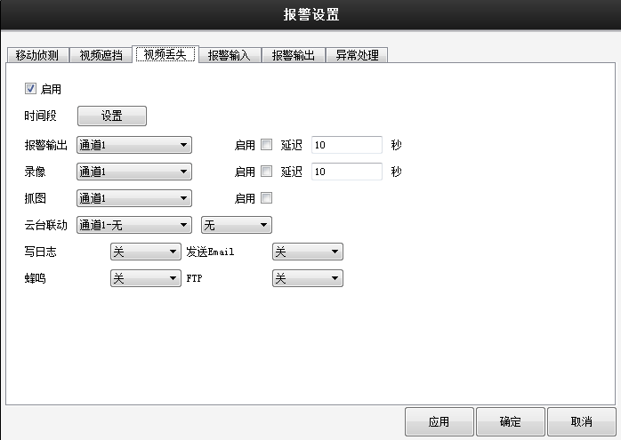

Select the alarm input option, as shown below:

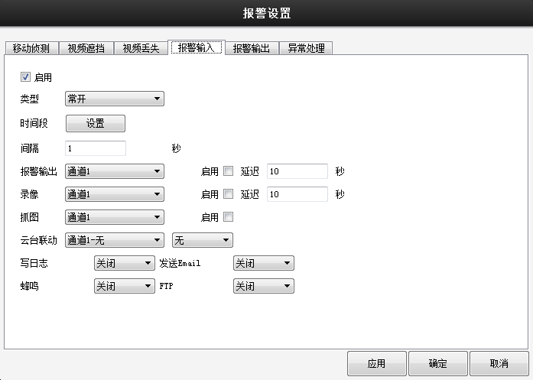

"Type" external alarm equipment output is the switching semaphage, alarm status needs to match the alarm type of the recorder, that is, the alarm device for the normally open video recorder equipment type needs to be set to normal open, and vice versa is normally closed;

Other settings options are described in "Mobile Detection" above;

Select the alarm output option, as shown below:

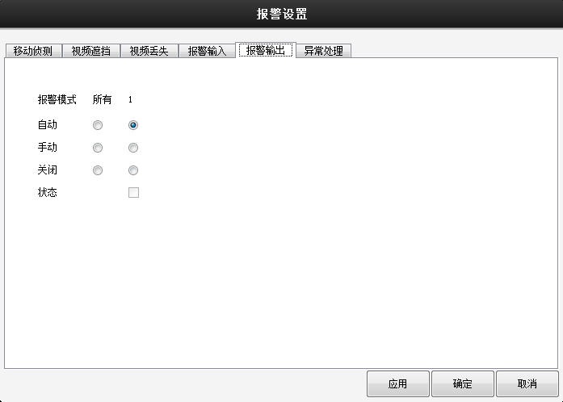

According to the configuration parameters, the alarm signal output is carried out.
No matter what state the channel alarm output setting is in, after selecting the "Manual" button, the corresponding channel always has an alarm signal output;
"Off" regardless of the channel alarm output settings in what state, select the "off" button, the corresponding channel will not produce an alarm signal output;
Status: Check indicates that there is currently an alarm signal output, and if not selected, there is no alarm signal output.

Select the exception handling option, as shown below:

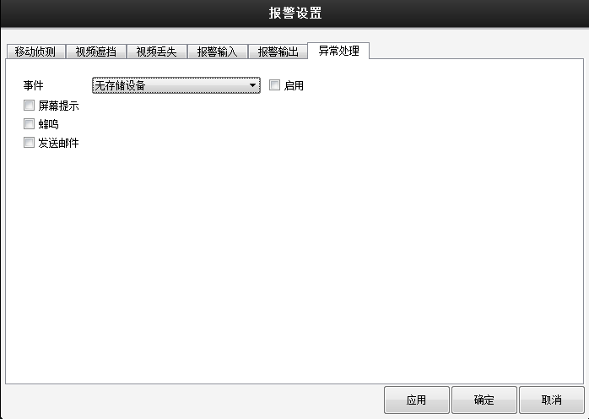

Event Type The event type can choose no storage device, insufficient storage space, storage device error,IP conflict, network disconnect

Internet
Click the network button 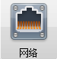to open the network settings interface;

TCP/IP settings
Select the TCP/IP option, as shown below:

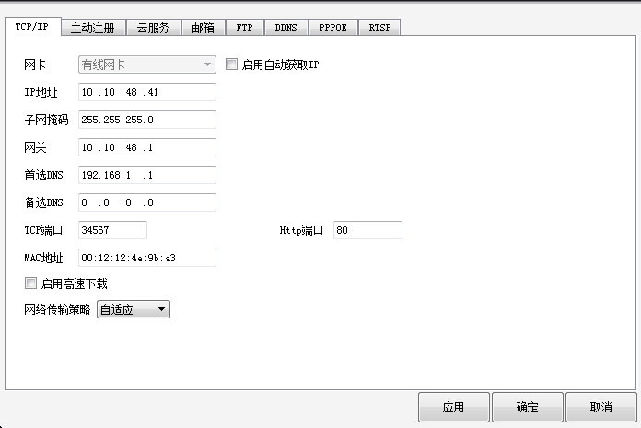

Network Card shows the type of network card currently in use
IP Address configures the IP of the device
Subnet Mask: Configures the subnet mask of the device
Gateway: Configure the gateway for the device
Preferred / Alternative DNSconfigures the DNS for the device
TCP Port configures the TCP of the device
Http Port configures the http port of the device
MAC Address displays the MAC address of the device
Enable high-speed download check high-speed download, download speed will be improved
Network Transport Policy: Optional Adaptive / Picture Quality First / Smooth Priority / Network Communication First

Actively register settings
Select the active registration option, as shown below:
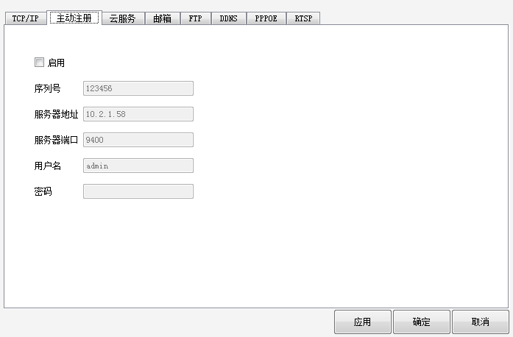

Enable active registration after checking
Serial number: Configure the serial number of the device
Server Address: Configure the server address of the device
Server Port: Configure the server port of the device
User Name: Configure the user name of the device
Password: Configure the password for the user name

Cloud service settings
Select the cloud service option, as shown below:

Enable: Enable cloud service after check, cloud service enabled, users can use the video recorder unique serial number login http://www.xmeye.net remote preview, management recorder
MTUconfigures the value of the MTU

Mailbox settings
Select the mailbox option as follows:

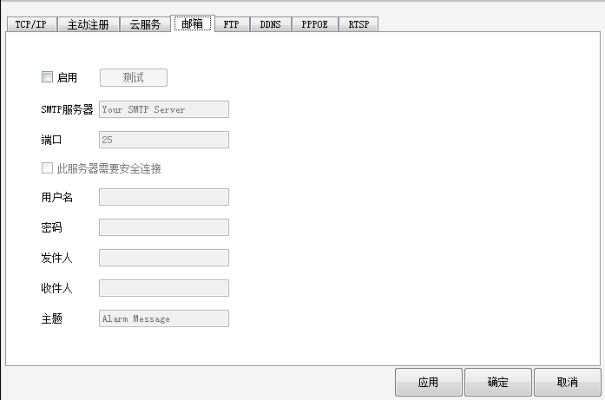

EMAIL is used to send alarm messages and pictures to specified mailboxes via the set send mailbox when an alarm is generated by the recorder;

SMTP Server Mail Outbox SMTP server address, can be a specific IP address or domain name (if the domain name requires confirmation that DNS is set up correctly, the domain name can be resolved correctly);
Port: Mail server port number;
SSL:The server requires that you log in using the Secure Socket Layer;
User name, password: the username and password of the outbox;
The sender's specific email address is fully named;
To receive the full name of the email address of the alarm message, can set up to 3 recipients, separated by a semicolon;
Subject: The subject of the alarm message, which users can set according to their own needs.
Mail Test: After filling in the above information, click the mail test button to set up information and video recorder network environment to test, if the test success inbox will be tested mail, otherwise prompt the test failure, test failure please check the configuration information and network conditions are normal.

FTP settings

Click on the"FTP"option to enter the FTP interface, as shown below:

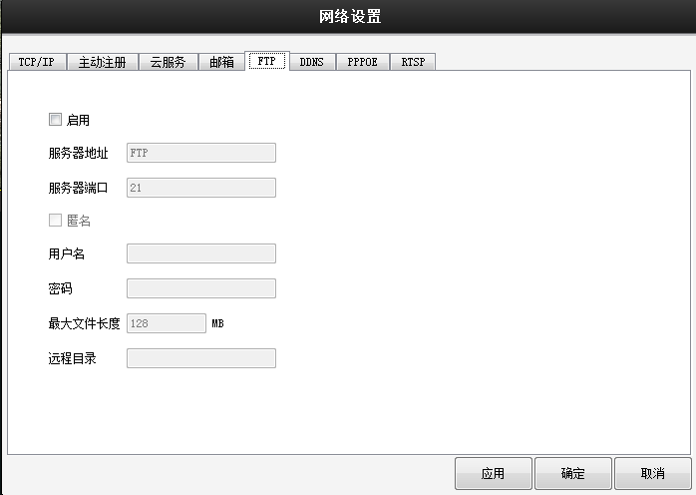

Host IPspecifies the IP address of the FTP server, and if the FTP server is located on the WAN, the recorder also needs to connect to the WAN;
Port: The domain port number set when theFTP server is set up, the default port 21;
User name, password: A user name and password with the appropriate permissions registered on the FTP server;
Anonymous: You can upload files to the FTP server without using your username and password after selecting, and you need to confirm that FTP can be accessed anonymously before using this feature;
Maximum file length: The maximum length of each package upload file, the default is 128M;
Remote Directory: File directory for uploading files.
Note: The username is authorized to upload files to the server.

DDNS settings

Click on the"DDNS"option to enter the DDNS interface, as shown below:

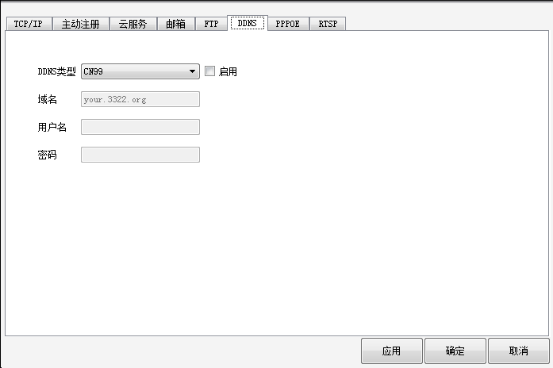

DDNS Type selects the manufacturer that provides dynamic domain name resolution services.
The domain name bound to the VCR IP is generally the domain name obtained by the service provider that provides the domain name resolution
User name, password: the username and password registered at the domain name resolution service;
Note: The correct DNS settings are required in the network settings

PPPOE settings
The recorder connects to the WAN via the PPPOE feature for remote access, which requires a dedicated PPPOE dial-up network.

Click on the"PPPOE"option to enter the PPPOE interface, as shown below:

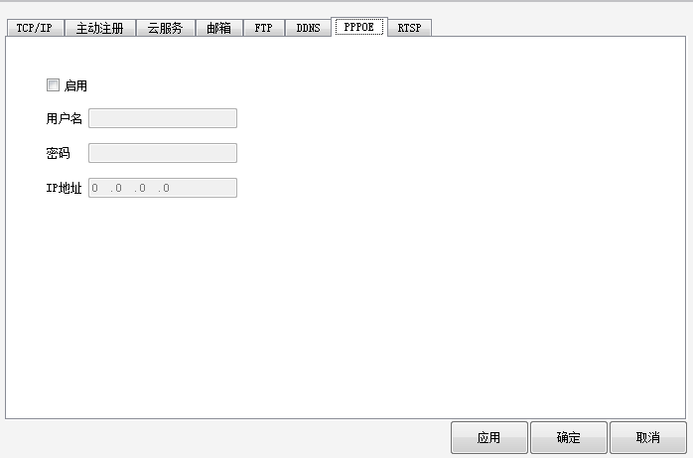

Check the enable box to enable PPPOE dialing;
User name, password: Enter the PPPoE username and password provided by the operator, re-start the recorder as prompted after saving, automatically establish the network connection by PPPoE after starting the video recorder, and automatically display the acquired WAN IP address in the IP address bar.

RTSP settings
Video preview of the recorder through non-IE kernel browsers (Apple, Firefox,google) and streaming software.

Port: The default port set by the device is 554.

User management
Click the User button to 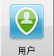enter the User Management interface, as shown below:
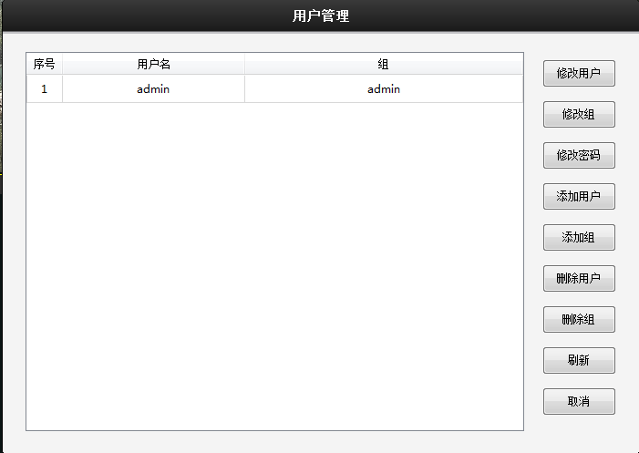

Can add, modify, delete users, etc.

System settings

Click the system button 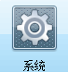to enter the system settings interface

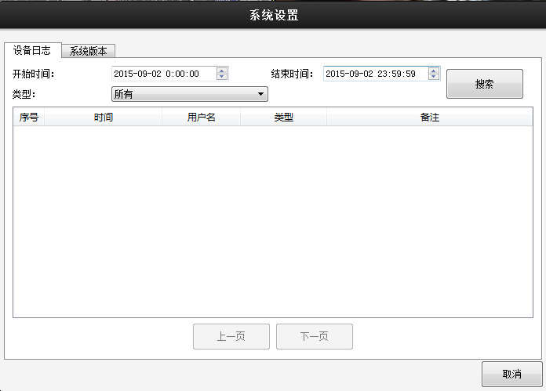

Set the start and end times, modify the type of action, and search for device log information.

Version information

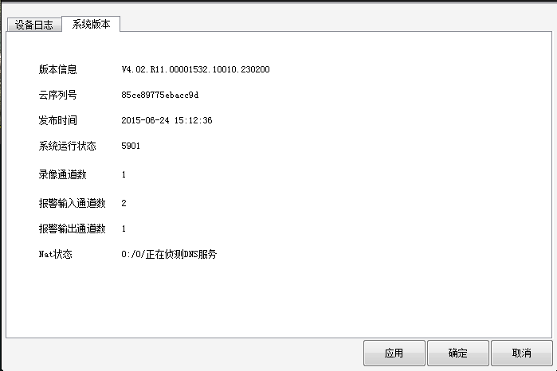

Displays the version information for the device

Click the exit button 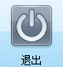to exit the remote configuration menu

